Visit Activity

Now run below command to run our local host to redis server

podman run -p 8081:8081 rubal15/visits

This command will say connection refused as we forgot to run redis is which is running on 6379 so our application is not able to connect to redis server

Check the localhost 8081 on the browser “localhost:8081” it is giving error

Now modify the command and run the below command to start the redis server

podman run -d -p 6379:6379 redis

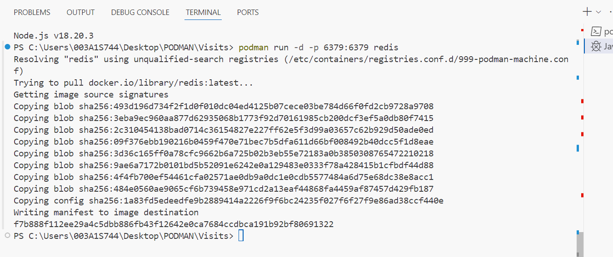

Now create the docker-compose.yml file this will connect two containers together i.e Node App container and Redis container

And add below lines in the index.js file

Run below command in the console that will build and compose podman and your localhost 8081 will start running:

Podman compose build

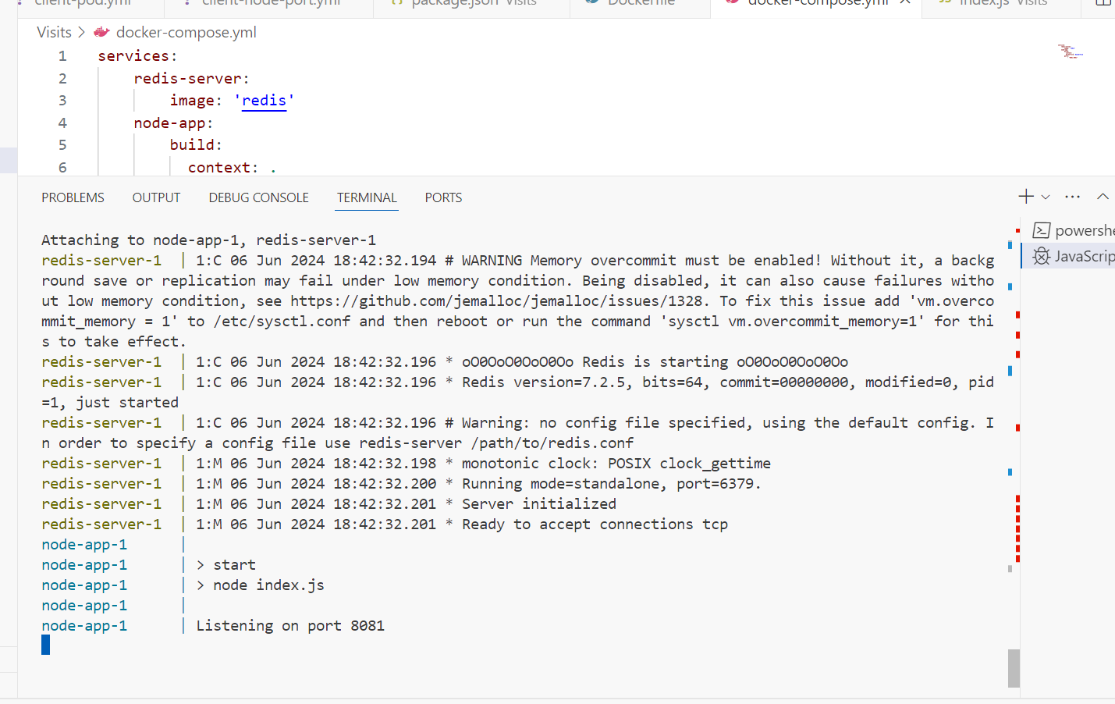

Now go to the browser and run “localhost:8081”

Refresh number of visits increses

